Festival Inter’Nature Haut-Jura
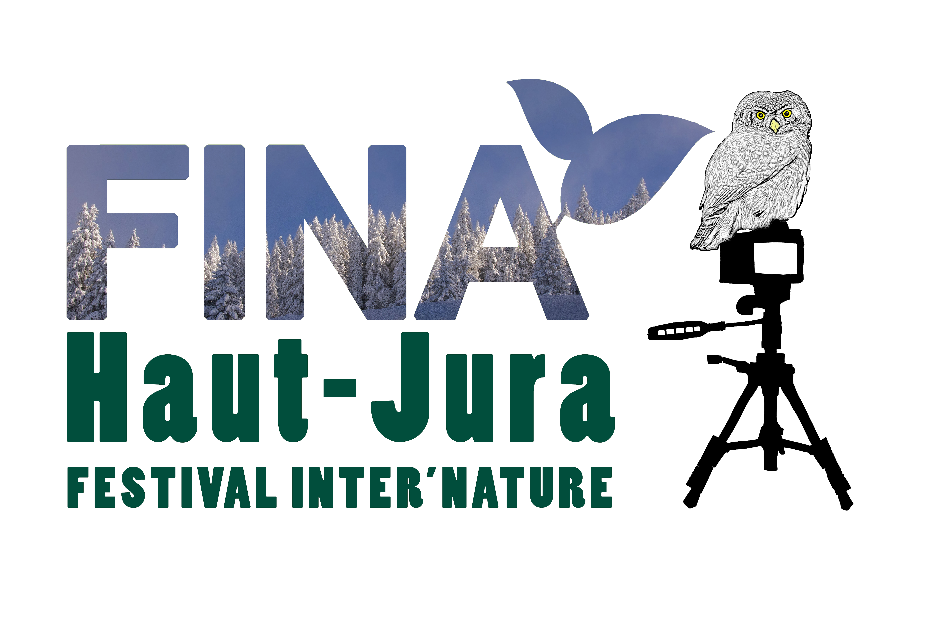
Friday 31st March, Sat. 1st and Sun. 2nd April, 2023

APPLICATION FORM (until 15th September, 2022)
Surname | First Name
Street, number | Post code
City/Town | Country
Phone number | Email address
Website, Facebook, Instagram… (optional)
Please select the nature of your presentation
PICTURES | OTHERS
 Fauna | ❑ Presentation
❑ Flora | ❑ Film
❑ Landscape |   Conférence
❑ Other, indicate
Topic / Title for the exhibition : | Topic, duration and file format (MP4, Powerpoint etc…) :
 | Film converted to DCP : YES  NO 
Acceptance (mandatory check box)
   I certify, that I have read and understood the conditions of participation FINA 2023 and that I agree with all its parts
Date, Signature :

